
Worship Palm Sunday
April 10, 2022
Calvary and Zion United Methodist Churches
Welcome:
God is Light, in whom there is no darkness at all. For God sent His Son into the World, not to condemn the World, but that the World might be saved through Him.
Hymn: Hosanna, Loud Hosanna

Call to Worship:
We praise you and bless you, ever-living God, for your acts of love by which you redeem the world through Jesus Christ our Lord. This day he entered the holy city of Jerusalem and was proclaimed king by those who spread their garments and palm branches along His way. Let these palms be for us sign of His victory; and grant that we who bear them may always claim Jesus as Messiah by walking the way of His suffering and the cross; that, dying and rising with Him, we may enter into your Kingdom. Through Jesus Christ, who lives and reigns with you for ever and ever. Amen

Hymn The King of Glory Comes
Prayers For Others: Take some time to pray for those on our list and any others that come to mind.
Lord’s Prayer: Our Father, who art in heaven, hallowed be thy name; thy kingdom come; thy will be done; on earth as it is in heaven. Give us this day our daily bread. And forgive us our trespasses, as we forgive those who trespass against us. And lead us not into temptation; but deliver us from evil. For thine is the kingdom, the power, and the glory, for ever and ever. Amen.
Cares Chorus: I cast all my cares upon You -- I lay all of my burdens down at Your feet
And any time I don't know what to do, I will cast all my cares upon You.
Offertory: What will you offer to God this week?
Birthdays: Pauline Peterson 4/13, Emmett Moroney 4/13, Marcy Rose Desotelle 4/14
Scripture: Zechariah 9:9-11
⁹ Rejoice greatly, O daughter Zion! Shout aloud, O daughter Jerusalem! Lo, your king comes to you; triumphant and victorious is he, humble and riding on a donkey, on a colt, the foal of a donkey. ¹⁰ He will cut off the chariot from Ephraim and the warhorse from Jerusalem; and the battle-bow shall be cut off, and he shall command peace to the nations; his dominion shall be from sea to sea, and from the river to the ends of the earth.
Mark 11:1-11
When they were approaching Jerusalem, at Bethphage and Bethany, near the Mount of Olives, he sent two of his disciples ²and said to them, ‘Go into the village ahead of you, and immediately as you enter it, you will find tied there a colt that has never been ridden; untie it and bring it. ³If anyone says to you, “Why are you doing this?” just say this, “The Lord needs it and will send it back here immediately.” ’ ⁴They went away and found a colt tied near a door, outside in the street. As they were untying it, ⁵some of the bystanders said to them, ‘What are you doing, untying the colt?’ ⁶They told them what Jesus had said; and they allowed them to take it. ⁷Then they brought the colt to Jesus and threw their cloaks on it; and he sat on it. ⁸Many people spread their cloaks on the road, and others spread leafy branches that they had cut in the fields. ⁹Then those who went ahead and those who followed were shouting, ‘Hosanna! Blessed is the one who comes in the name of the Lord! ¹⁰ Blessed is the coming kingdom of our ancestor David! Hosanna in the highest heaven!’ 11 Then he entered Jerusalem and went into the temple; and when he had looked around at everything, as it was already late, he went out to Bethany with the twelve.
Message: Even the King Needs Encouragement
Jesus entering Jerusalem on the donkey is a visual parable. In a parable what you think is the outcome is often quite different than what you expect. Jesus takes what people would expect and turns their expectations upside down. Jesus decides to show that his kingdom is quite different than any of the kingdoms in the world
This event comes after Jesus had called his friend Lazarus from the tomb. Jesus was known to the people who lived in Bethany and in the region around the Mt. of Olives. The raising of Lazarus from the dead enhanced Jesus standing in and around Bethany. Jesus decided to make this entry into Jerusalem a formal entry as a new ruler might make an entry to the city. When a ruler made the first entry to the city the ruler would come in a procession. The procession would have the ruler dressed in expensive royal clothes, riding a war horse or chariot. There would be men-at-arms following to show how much power the new ruler controlled. Along the procession route people would cheer the new ruler. The whole procession would give the people of the city an idea of how the person would rule the city and the measure of their strength.
Jesus rides not a war horse but a donkey. His men at arms carry no weapons. The people cheer him by waving leafy branches. Jesus is not dressed like a royal person but like one of the crowds cheering Him. By his manner of entering Jerusalem, Jesus shows that he is fulfilling the prophecy that the Messiah will be humble and not war like.
In a field ed. assignment in Seminary, Michael Williams and I worked at Broadway UMC in Chicago. We were in charge of the Sunday School. On Palm Sunday we were trying to think of a way to teach the kids about the day. We came up with a game where a child would sit in a chair with the rest of the children sitting in a half circle around the chair. One by one the rest of the kids tell the person in the chair something good about them. They would say how nice their shirt or pants looked, or shoes were, they would say how nice their eyes or hair was, or just tell them how great they were. They kept up the complements till they ran out and the next person would take the chair and the process would be repeated. We did this till all the children had a turn in the chair. At the end Michael & I were going to make some great theological points but before that happened the kids said, “could we do that again.” Well of course we did the game again and again till the hour was up. We told the children that the way you felt when you were in the chair was how Jesus felt riding on the donkey into Jerusalem.
After that experience, I have wondered if after all the symbolic meaning has been examined and all the Biblical accounts have been analyzed that really Jesus needed this time of being hailed as the King because the next week was going to be the hardest in his life. We all need to be told, from time to time, that we are not only loved but that we are the greatest.

Further Study:
Mark 11:1-2
¹When they were approaching Jerusalem, at Beth phage and Bethany, near the Mount of Olives, he sent two of his disciples ²and said to them, ‘Go into the village ahead of you, and immediately as you enter it, you will find tied there a colt that has never been ridden; untie it and bring it.

The Mount of Olives is a short distance from the entrance to the Temple Mount, in Jerusalem. Bethany is on the west side of the hill called the Mt. of Olives. Beth phage is a very small village (really a collection of houses) a Sabbath’s day journey (the distance a person was allowed to walk on the Sabbath) from the temple court. It is about a mile walk in total. It was Jesus’ intention to dramatize who He was. He was preparing a living parable.
Question: Have you ever been in a parade? Would you rather be in one or watch one?
Challenge: Take a walk this week of at least a mile. Do this each day and while you walk think about your life to date.

Mark 11:3
³’If anyone says to you, “Why are you doing this?” just say this, “The Lord needs it and will send it back here immediately.”

The reason they were willing to give up the colt so quickly is found in the statement “the Lord” has need of it. This is not Jesus’ first trip to this area. In fact, He has been here a number of times. He is well known by the people in the villages on the Mt. of Olives. They knew He was Lord so the title the disciples used told the person with the colt that God was calling them to give up something valuable for the kingdom. We never know when God will call upon us to give up something important for the kingdom.
Question: How do you like horseback riding?
Challenge: When have you felt “someone” saying to you, “the Lord has need of it”?
Mark 11:4-6
⁴They went away and found a colt tied near a door, outside in the street. As they were untying it, ⁵some of the bystanders said to them, ‘What are you doing, untying the colt?’ ⁶They told them what Jesus had said; and they allowed them to take it.

This sounds like a repeat of the verse above. The difference is that in verse 3 Jesus is telling what the disciples can expect. In verse 4 the disciples are experiencing the truth of what Jesus told them. We have heard the good news of God’s love but until we accept and experience that sense of forgiveness that comes from God it is just information. It does not become personal until we experience it. This is why we must help people experience the love of God, that love we have already experienced. We cannot preach the word until we have believed it ourselves.
Question: What are the three most valuable things that you have?
Challenge: What would it mean for you to give the best or most valuable things you have to God?

Mark 11:7-8
⁷Then they brought the colt to Jesus and threw their cloaks on it; and he sat on it. ⁸Many people spread their cloaks on the road, and others spread leafy branches that they had cut in the fields.

Jesus picks a colt to make His entry because he wanted to place emphasis on the fact that His kingdom is of a different nature. He comes not as a conquering hero on a war horse, but as the king of peace. He brings a kingdom that has hope for humanity and comes from God. Spreading cloaks and waving branches was a way to honor someone.
Question: Today, how do we show respect for someone in a parade?
Challenge: If God will bring about the kingdom when God wants to, why should we work to bring it about?

Mark 11:9
⁹Then those who went ahead and those who followed were shouting, ‘Hosanna! Blessed is the one who comes in the name of the Lord!

One of the things the crowd did for Jesus was to acknowledge Him as Lord. In effect they were saying that He was the greatest. This kind of affirmation was needed by Jesus so he could go through the days to come. In the days to come some of the same people would call for his death. For now, the crowd recognized Jesus as the King and was willing to proclaim it for all to hear.
Question: What good news have you shared this week?
Challenge: List five things about yourself that are outstanding.

Mark 11:10

¹⁰Blessed is the coming kingdom of our ancestor David! Hosanna in the highest heaven!’

The hope of the people in Judah at this time was that God would now establish the new kingdom on earth. They believed that God loved them, and they believed that God, the creator and covenant God, would finally bring them back from exile. They did not know exactly how this would happen and they especially did not know when. They knew it would be soon, but they did not know how soon. There were plenty of opinions as to how and when and what they should do to prepare. All of these opinions contributed to the leaders not recognizing Jesus as the one they waited for and the time of redemption being now. Palm Sunday was a brief time when both Jesus and the crowd, on Palm Sunday, experienced and expressed the joy of God’s promise fulfilled. They hailed and acknowledged Jesus as Lord.
Question: How do you think the crowd knew to hail Jesus as king?
Challenge: Easter is coming in seven days. Write down how you have experienced the resurrection.

Closing Hymn: Filled with Excitement
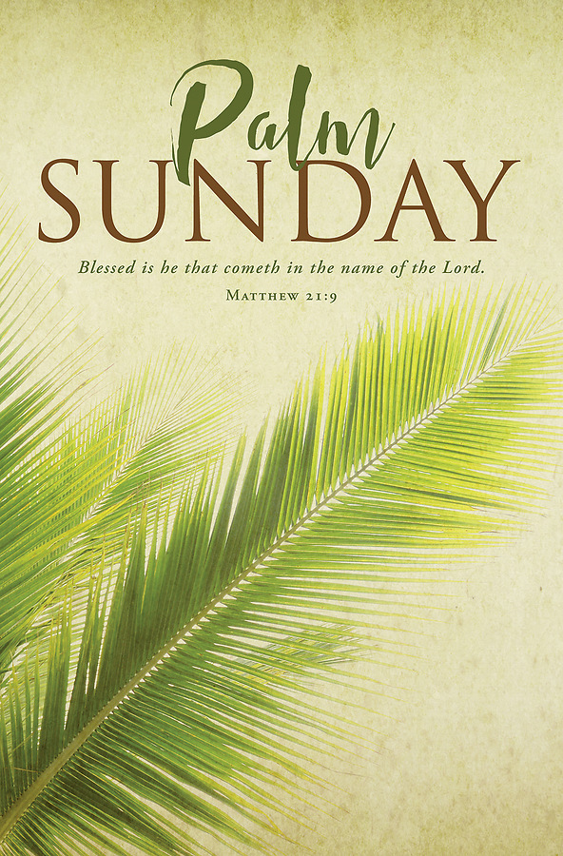
Benediction May we hold fast to Jesus’ vision of goodness—Peace from the practice of justice, equality from the practice of respect. As this week unfolds, we will let ourselves be overtaken by God’s love and we will pour it back out into the world.

Calvary/Zion United Methodist Churches
We Are Merging Excitement and Hope
Into a Vital Faith
Our Prayers
God’s Healing Touch
Bob & Barb Cable, Don Olson, Melvin Pfister
Ralph & Georgeen Taylor, Mark Rieland, Eugene Gauger (Roy’s Brother),
Marcy Desotelle, Curt Mingle, Deb Harding, Paula Desotelle, Dennis Wojahn,
Natasha (Don Heeringa’s daughter in law) Michael Williamson- Roberta Dietrich (Joan’s sister)-- Kirby & June Anderson, Mar Jean Buck, Atticus Jenkins,7 months (Rix’s GGson)
Members Who are Homebound or are in Care Facilities.
Evelyn Mueller, Mary Ann Masson, Juanita Alley, Darlene Reinhard
For Those Who Are in Mourning
The family of Sue (Bev Schultze cousin. Died in a car accident)
Those Serving in the Military and Others in National Service
Marines
Gabriel Holcomb, Adam Reinhardt, Samuel Carrasco
Air Force
Sarah Carrasco, James Fouts, Paul Lewis
Army
Sam Walters, Scott Kokjohn, Ian Smith
Navy
Jake Vallone, Derek Olsen, Brian Olsen, Jared Hentz
In Our Community and World
For all those suffering in the Ukraine war.
For all of those looking for homes in our community

APRIL MISSION OF THE MONTH:---ASSISTANCE FOR DISASTER VICTIMS

The Mission of the Month for April will benefit the Midwest Mission Distribution Center that was established in 2000 to provide disaster relief supplies that meet basic human needs “around the world and around the corner.” It is one of nine cooperating depots in the United Methodist Committee on Relief (UMCOR) supply network and also partners with five other relief agencies. All supplies are given free of charge, regardless of gender, race or religion.
Donations to the mission are used to purchase items in bulk at greatly reduced costs.

Contributions, marked Midwest Mission Distribution Center, can be sent to Calvary UMC, Box 168, Egg Harbor, WI 54209, or Zion UMC, Box 344, Fish Creek, WI 54212, or designated as Mission of he Month in the Sunday offering. Thank you for your generous response to this mission effort



